Healthy Refried Beans

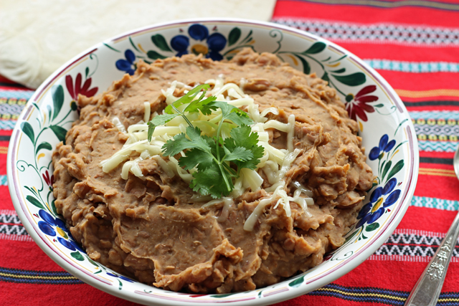
Ingredients:
- 2 cans of low-sodium or no salt added pinto beans, drained and rinsed
- ½ onion, diced
- 1 tsp. of butter
- 2 garlic cloves, chopped
- 1 tbsp of paprika
- 1 ½ tsp. salt
- 1 ½ tsp. cumin
- For topping: scallions, tomatoes, diced avocado (or any veggies in your refrigerator)

Directions:
- In a skillet, sauté the onion and garlic in butter over medium-high heat until lightly golden, roughly 2-3 minutes.
- Using a large spoon, transfer the beans to a food processor. Add the sautéed onion and garlic to the food processor along with paprika, salt, and cumin. Process until smooth, or add water to achieve smooth consistency.
- Remove mixture from food processor and serve with scallions, tomatoes, and/or diced avocado as toppings.

Healthy Fried Rice

Ingredients:
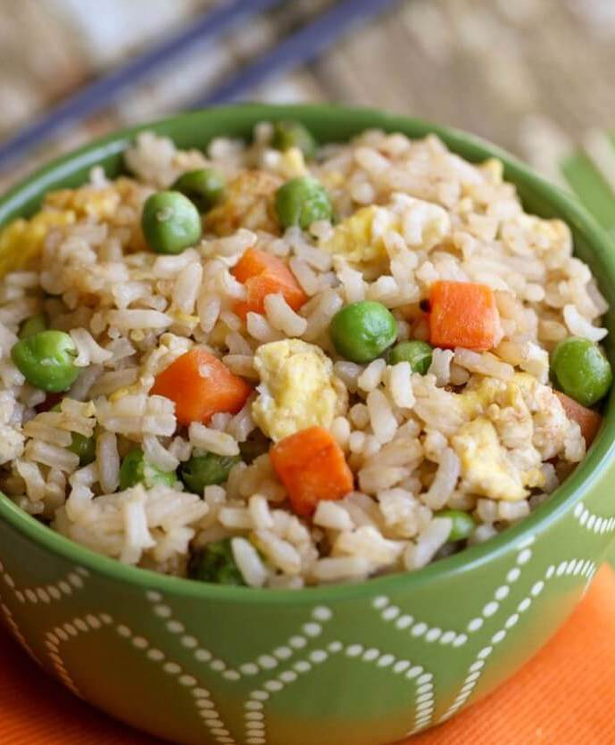
- 2 c. of cooked brown rice (or use “riced” cauliflower)
- 2 tbsp. sesame or canola oil
- 1 can of low-sodium or no salt added peas (or 1.5 c frozen peas)
- 2-3 carrots, shredded
- 1 garlic clove, minced
- 2 eggs, slightly beaten
- ¼ c. low-sodium soy sauce
Directions:
- In a skillet, heat oil (sesame or canola) on medium-high heat.
- Add shredded carrots, peas, and minced garlic to the skillet. Cook until tender (8-10 minutes).
- Lower the heat to medium-low and push vegetable mixture to one side.
- On the other side of the skillet, add slightly beaten eggs. Cook until scrambled.
- When eggs are scrambled, add cooked brown rice (or “riced” cauliflower) and low-sodium soy sauce. Mix all together and cook until all ingredients are thoroughly heated.

Black Bean and Vegetable Quesadilla

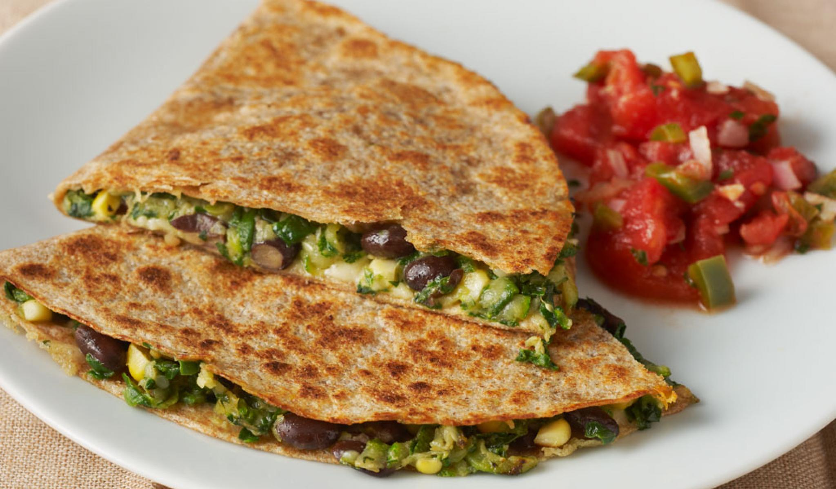
Ingredients:
- 1 can low-sodium or no salt added black beans, rinsed and drained
- 2 medium zucchinis, thin slices or grated
- 1 bunch of spinach (about 4 cups), chopped
- 1 c. low-sodium or no salt added canned corn, rinsed and drained
- ½ c. of full-fat cheese
- 1 tbsp. canola oil
- ½ tsp. ground black pepper
- 6 whole-wheat flour tortillas
Directions:
- Rinse and prepare zucchini, spinach, and corn.
- Heat oil in a large skillet over medium-high heat. Add zucchini and cook until zucchini is semi-soft (roughly 5 minutes). Add corn and spinach, and cook until all ingredients are tender (roughly 5 more minutes). Remove from heat and place in a medium-sized bowl.
- Add black beans and black pepper to the veggie mixture. Stir to combine. Add 1-2 tsp. of water and mash beans lightly with a fork to create a paste.
- Spread vegetable mixture evenly on half of a tortilla. Add shredded cheese on top of the mixture and fold the tortilla over. Press with spatula to flatten
- Spray skillet with non-stick cooking spray and cook for 4 minutes per side, or until both sides are golden brown.
- Remove from heat and cut each quesadilla into wedges.

Chicken Quesadilla

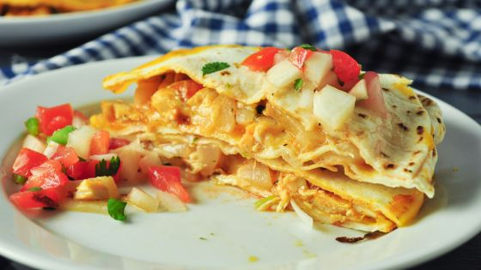
Ingredients:
- 1 lb. shredded chicken (use leftovers if you have them!!)
- 1 onion, chopped
- 2 peppers, chopped (red, green or yellow)
- 1 tbsp. canola oil
- ½ tsp. ground black pepper
- 6 whole-wheat flour tortillas
Directions:
- Rinse and prepare onion and green peppers.
- If you are preparing the chicken, season chicken with salt and pepper before roasting/baking/poaching. When cooked, shred or dice the chicken
- Heat oil in a large skillet over medium-high heat. Add onion and green pepper and cook until everything is tender (roughly 5 minutes). Remove from heat and place in a medium-sized bowl.
- Spread vegetable and mixture evenly on half of a tortilla. Add shredded cheese on top of the mixture and fold the tortilla over. Press with spatula to flatten
- Spray skillet with non-stick cooking spray and cook for 4 minutes per side, or until both sides are golden brown.
- Remove from heat and cut each quesadilla into wedges.
Note: Get creative and use any leftover vegetables you have in place of peppers.

