“Top – It – Your – Way” Beans
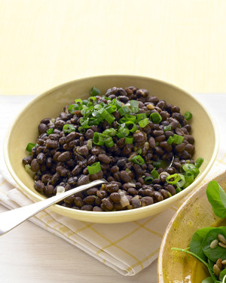
Ingredients
- One, 15 ounce can of pinto or black beans, rinsed and drained (choose a brand with <300 mg sodium per serving),
- One small jalapeno pepper (optional)
- 1 tsp. garlic powder
- 2 tsp. olive oil
- Chopped cauliflower (also known as “riced” cauliflower), or small amount of brown rice
Ideas for “Toppings”: Place each individual topping into a bowl or small plate.
- Cooked, chicken, cut into bite - sized pieces (this is a great way to use left-over chicken!)
- Fresh, snipped cilantro
- Shredded cheese (cheddar, Colby jack or any mixture of favorite cheeses)
- Sliced black olives
- Thinly sliced (or shredded cabbage)
- Fresh slices of lime
- Thinly sliced fresh jalapenos (for those who LOVE it hot!!)
- Chopped fresh tomatoes
- Salsa
- Sliced avocado
- Tortilla chips, broken
Directions
- In a medium pot, sauté jalapeno pepper in olive oil, over low heat until tender.
- Stir in beans.
- Add garlic powder and mix well.
- Simmer until heated all the way through.
- In medium bowl, serve beans over “riced” cauliflower or small amount of brown rice.
- Add three or more toppings from the list above (or come up with your own ideas!)
Note: Allow one can of beans for every 3 people!

